# SublimeApex Guide

## [Preface](app:ds:preface)

SublimeApex is the plugin of Sublime Text 3 for windows. All source code is written by native python.

This tool is used to replace development functionality of Force.com IDE, and some other purpose, for example, export workflow, validation rule and batch backup data.

All operations on apex code are asynchronous, which will not block your other operation.

As we know, Force.com IDE code suggestion is not very well, however, this plugin will supply enough suggestion when you are coding.

## Installation

Before you start your journey on SublimeApex, you should install Sublime Text 3 (hereinafter referred to as ST3).

You can find the ST3 portable version at [here](http://www.sublimetext.com/3). After ST3 is downloaded, just put it in any path, and then download [SublimeApex in github](https://github.com/xjsender/SublimeApex/archive/master.zip), at last, extract the zip file into your sublime package path. Package Name in sublime should be SublimeApex, for example, "D:\Sublime347\Data\Packages\SublimeApex" is my installation path.

Correct installation path should be as below screenshot.

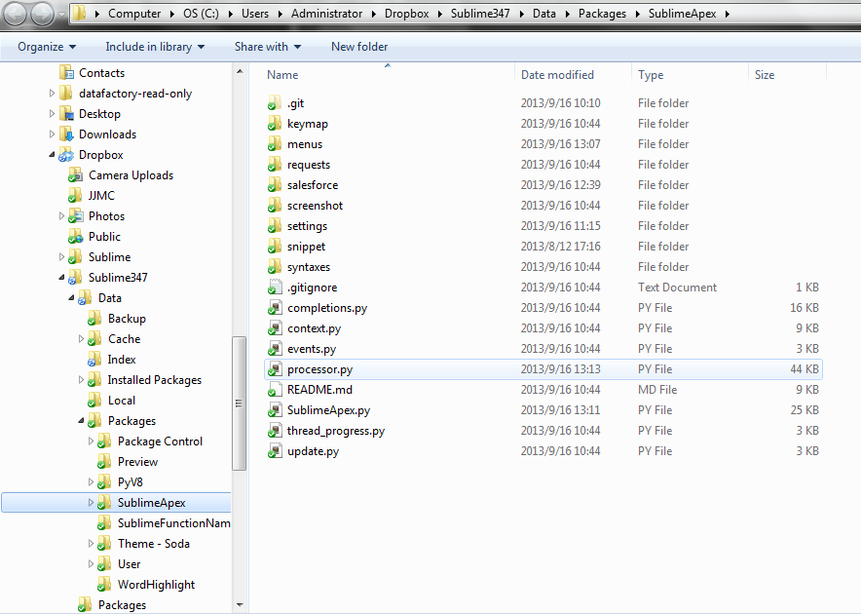

## Configuration

Before start coding, you should initiate your project settings, you can keep your settings in Default Setting or User Setting, however, [User Settings] is prior to [Default Settings].

In order to prevent plugin update overriding your toolingapi settings, you should keep your custom settings into [Setting - User] by clicking [SublimeApex > Setting - User].

You can setup your projects follow below sample by clicking "Setting - User" in the main menu, projects must be included in {}.

When you initiate your settings, you can have more than one project in "projects", however, only one project default can be true.

If your project need security token, just put it follow "username".

Every time you want to switch the project, you can click [SublimeApex > Switch Project] in the main menu and choose that you want, and then the update projects settings will be saved to user settings.

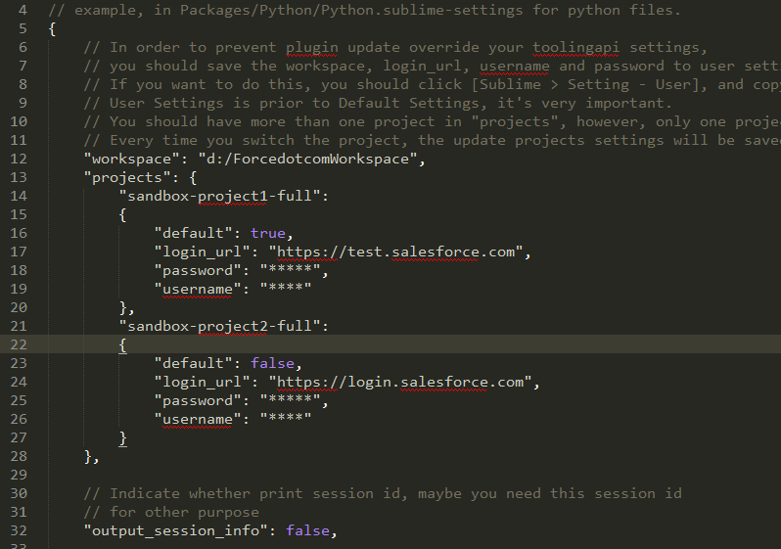

## Development

### 3.1. New Project

After you store the user credentials of your projects into the Sublime Settings, there will have only on default project, which means, you can only update the code of the default project, if you want to update the code of other project, you should switch project firstly by clicking *[SublimeApex > Switch Project]* in the main menu.

Click the *[SublimeApex > New Project]* in the main menu to download the code of the default project from server, after you click the command, a new project will be shown at the sidebar location, moreover, if you click this command again, you will refresh the default project from server.

At the same time of new project, all sobject completions will be refreshed, which means, all the new fields after new project will not be shown in the sobject completions, however, if you want it, you should click new project command to refresh the sobject completions again.

### 3.2. Apex Code CRUD

#### 3.2.1. New Component

Press “ctrl+alt+n” to invoke the input panel, and then input the new component info according to guide as below

You can invoke the new component command in the Sidebar Menu and Main Menu

*1. Create new trigger: Trigger-Name.trigger, Sobject-Name*

*2. Create new class: Class-Name.cls*

*3. Create new component: Component-Name.component*

*4. Create new Page: Page-Name.page*

#### 3.2.2. Save to Server

When you made some update on your apex code, you want to save it to server, you can press “ctrl+alt+s” or use your context menu to save it to server.

Because this operation is asynchronous, you can see the thread progress in the status bar, if compile has no error, you will see the success message in the status bar, and maybe you notice that there have default project parts in the most left part, which will tell you which project is default one now and prevent conflict.



However, if compile failed, the console panel will be open automatically and you will see the error info in the console

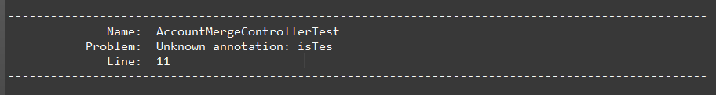

When you want to correct the code according to the error message and you made update, at the same time, console will be hidden. This functionality can be closed in sublime settings by setting “hidden_console_on_modify” to false.

#### 3.2.3. Refresh from Server

Maybe you update the apex code in the server and you want to get the newest version from server, you can press “ctrl+alt+r” or use your context menu to refresh from server.

Because this operation is asynchronous, you can see the thread progress in the status bar, if compile has no error, you will see the success message in the status bar,





However, if compile failed, the console panel will be open automatically and you will see the error info in the console

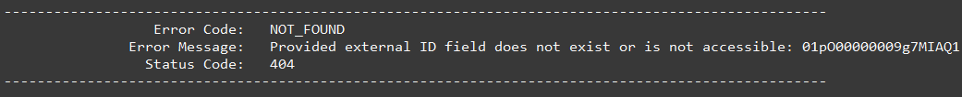

#### 3.2.4. Delete from Server

Maybe you created a class for testing some problem and you want to delete it, you can press “ctrl+alt+d” or use your context menu to refresh from server.

Because delete apex code is serious, you should confirm your action before delete it.

Because this operation is asynchronous, you can see the thread progress in the status bar, if compile has no error, you will see the success message in the status bar,



However, if compile failed, the console panel will be open automatically and you will see the error info in the console



#### 3.2.5. Refresh Folder

Maybe you created a class in server and you want to save it to local, you can press [“alt+r”, “alt+f”] or use [SublimeApex > Refresh Folder] in your main menu to save it to local.

Because this operation is asynchronous, you can see the thread progress in the status bar, if compile has no error, you will see the success message in the status bar, or if you want to see more detail information, you can press [ctrl+~] to open your console



However, if compile failed, the console panel will be open automatically and you will see the error info in the console.

#### 3.2.6. Refresh Project

Click New Project command means refresh project.

### 3.3. Apex Code Debug and Test

#### 3.3.1. Create Debug Log

If you want to track the debug log of a user, you need to login to Salesforce and create a new debug log for a new user, as my though, it’s not efficient, by this command, you can quickly create debug log for a user and no need to leave sublime text.

After you click this command and then wait for a moment, input panel with all active users in system will be shown. You can choose one from them, and wait for moment, you will see the success message in the status bar if no error.

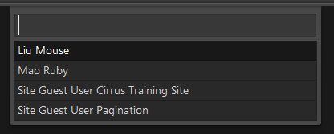

#### 3.3.2. List Debug Logs of Specified User

After you click this command and then wait for a moment, input panel just like above with all active users in system will be shown. You can choose one from them, and wait for moment; you will see a new view is open and debug logs are list as table format.

#### 3.3.3. Run Test Class in the Context

Before deployed, every apex code should have code coverage and total coverage of all apex code should be more than 75%, so you need to write your test class.

Open the test class and click [SublimeApex > Run Test] to run test class, during the long-time running process, you can see the progress in the status bar.



After test class running is over, you will see the test result in the new open view.

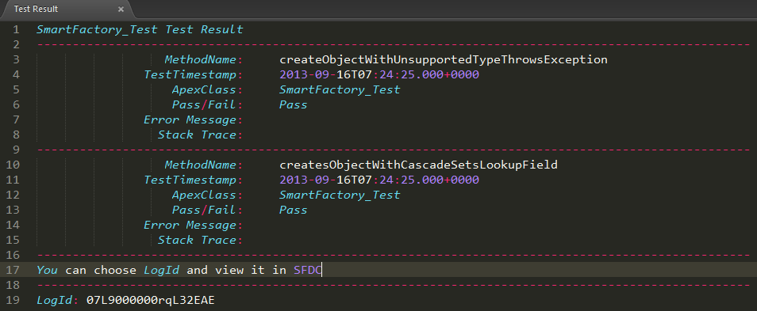

If error happened, console panel will be open automatically, you will see the error info as below.

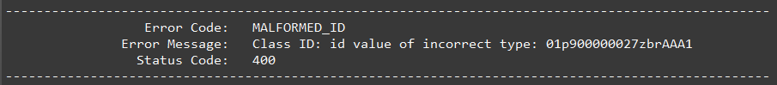

If Test Class Method failed, you must want to view the debug log detail, in this plugin, you can choose the LogId and click [SublimeApex > View Debug Log Detail] in the context menu.

#### 3.3.4. Run Specified Test Class

After choose a test class from the input panel, the next process will same with Run Test in context.

### 3.4. Completions (Code Suggestion)

#### 3.4.1. Apex Completions

After input dot in apex code, show sobject field and apex class completions

After List<, Set<, Map< in apex code, show sobject and apex class

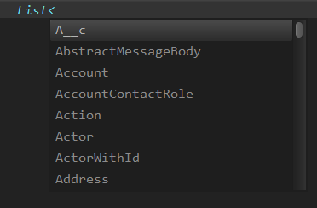

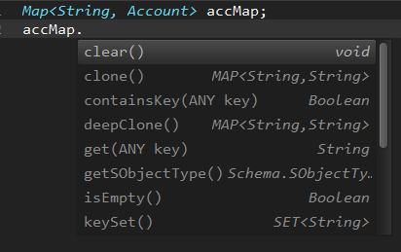

#### 3.4.2. Sobject Field Completions

You should add below setting to Perference > User - Setting, then you will have auto completions functionality.

1. After input dot in apex code, show sobject field and apex class completions

2. After input List<, Set<, Map< in apex code, show sobject and apex class

3. Input < in visualforce page, show all components.

4. Input <apex:page and space, show all attributes of this component.

"auto_complete_triggers":

[

{

"characters": ".",

"selector": "source.java"

},

{

"characters": "<",

"selector": "source.java"

},

{

"characters": "<",

"selector": "text.html - source"

},

{

"characters": ":",

"selector": "text.html - source"

},

{

"characters": " ",

"selector": "text.html - source"

}

]

At the same time of new project, all fields of sobject will be saved to local, every time you input a character after dot, plugin will get the sobject type of the variable name by regular expression, and then get the fields info of this sobject type from local repository and display them as below format. So the sobject completions will be very fast.

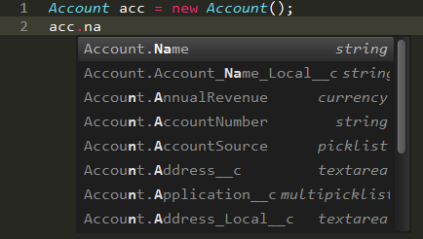

#### 3.4.3. Visualforce Page Completions

As we know, no one like write Visualforce code in the Force.com IDE, because after we want to save it to server, IDE will tell us there has error but never tell what error is, it’s very ugly, especially, and Force.com IDE doesn’t have page component completions.

With this plugin, every time you input <, you will see many page component snippets in the completions list, you can choose anyone.

After input the component name, input space, you will see many attributes of this component.

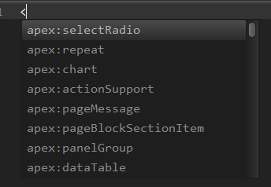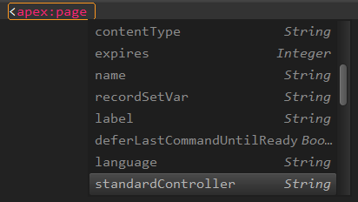

### 3.5. Utility

#### 3.4.1. Execute Anonymous

Choose any code snippet from anywhere and press [“ctrl+alt+e”] to execute it.

Maybe, you can put all anonymous code snippets in one view, every time when you want to test it, just choose the part you want to choose and then execute it.

Sometimes, you need to test code execution of different API version, you can edit the “api_version” settings in the [SublimeApex > Settings - Default]

#### 3.4.2. Execute Query

#### 3.4.3. View In Salesforce Web

#### 3.4.4. View Id In Salesforce Web

## Export Metadata as CSV

### 4.1. Export Workflow

### 4.2. Export Validation Rule

### 4.3. Export Sobject Workbook

### 4.4. Export Global Describe of All Sobjects

### 4.5. Export Layout Describe of Specified Sobject

### 4.6. Export CustomField of Specified Sobject

## Quick Login To

You can use these command to quick login to Salesforce and redirect to the corresponding location.

For example, you can click command to go to Home Page, Develop Console, Debug Log, Apex Job, Create Object, Create Workflow, Apex Test Execution and Specified Apex Code

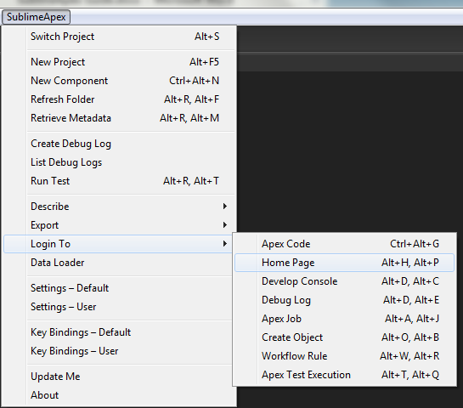

## Dataloader

### 7.1. Export All Data of All Sobjects

### 7.2. Export Specified Sobjects

## Metadata API

### 8.1. Retrieve

### 8.2. Deploy

Continue….